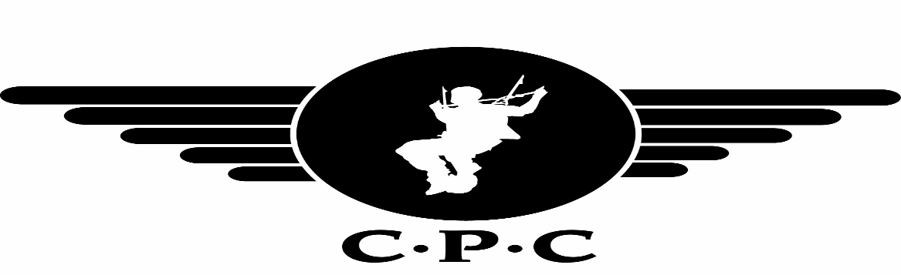

BOOKING FORM

NAME : _____________________________________________

ADDRESS : _____________________________________________

: _____________________________________________

: _____________________________________________

: ________________ POSTCODE _______________

TELEPHONE – HOME : _____________________________________________

TELEPHONE – WORK : _____________________________________________

EMAIL : _____________________________________________

AGE : _______________ WEIGHT : _______________ HEIGHT : ____________

I WISH TO ATTEND ON: ________________________ (day /date required)

TYPE OF DESCENT: * Charity Tandem Skydive / Tandem Skydive/Static Line/ AFF

14st (89 Kilo) limit. (If over this weight please contact the club)

To pay the deposit, please call 07792106619 for card payments or BACS

Bank: Lloyds Bank
The Cornish Parachute Club Ltd.
Account No: 02245248. Sort Code: 30-98-76
Alternatively, supply details below
* PLEASE DEBIT MY DEBIT CARD:

Visa Delta /Maestro(Dom) / Solo / Electron (Issue Number:___ )

Card Number: |  |  |  |  |  |  |  |  |  |  |  |  |  |  |  |  |  |  |  |  | CVC

Start Date: |  |  | /
Expiry Date: |  |  | /

* Delete as necessary. * All deposits are Non – Refundable.

